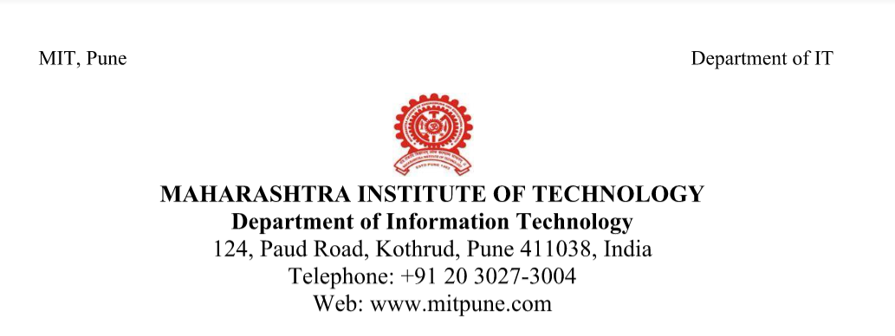

**Date: 26/02/2018**

**Roll No: 306006**

**Name: Harshali Bedmutha**

**Seminar Guide: Mrs. Himangi Pande**

**Title of the seminar: RNN(Recursive Neural Network) and LSTM (Long Short Term Memory)**

**Introduction:**

**Motivation:**

* RNN is widely used in stock market prediction.
* But there is a limitation of long term memory dependency to RNN which is overcome by a special type of RNN called LSTM
* LSTM is thus now widely used in many fields including stock market prediction.

**Objective:**

* To study RNN and LSTM.

**Brief description:**

Humans don’t start their thinking from scratch every second. As you read this essay, you understand each word based on your understanding of previous words. You don’t throw everything away and start thinking from scratch again. Your thoughts have persistence. Traditional neural networks can’t do this, and it seems like a major shortcoming. For example, imagine you want to classify what kind of event is happening at every point in a movie. It’s unclear how a traditional neural network could use its reasoning about previous events in the film to inform later ones. Recurrent neural networks address this issue. They are networks with loops in them, allowing information to persist. Long Short Term Memory networks – usually just called “LSTMs” – are a special kind of RNN, capable of learning long-term dependencies. LSTMs are explicitly designed to avoid the long-term dependency problem. Remembering information for long periods of time is practically their default behaviour, not something they struggle to learn. The seminar aims to study RNN and LSTM in detail.

[Signature] [Signature]

**Student** **Seminar Guide**